The Effects of Predation on Brain Development in Fish

Katherine Bol

Biology 461

West Virginia University- Institute of Technology

**Introduction**

Organisms of different types exhibit different brain sizes along with varying sizes of different region of the brain. Due to the brain of vertebrates having high plasticity, there is room for evolutionary changes. There are multiple different things that can cause a variation of the brain and brain structures, and it is different for almost all organisms. An increase of brain size is typically seen to have a positive correlation with increased cognitive function as well as learning capabilities (Walsh). Brain size of an individual will have trade-offs, like reproduction and energetic constraints, that are associated with entitlement towards brain tissue (Walsh). The energetic constraints theoretically impose a theory that there will be strong selection against any non- adaptive modifications (Gonda). Essentially, brain size is a large body of costs and benefits of fitness.

One big factor that can drive an organism to have an evolutionary change to their brain structure is the presence, or lack-there-of, of a predator. Predation is already a major force in the pushing for natural selection. It is already known that predation can cause an organism to have selection for their color and body armor, but the question is, how does the predation drive for selection of brain size? For starters it is important to look at the regions of the brain and see what they control. The telencephalon is responsible for integrating complex information, learning, and memory, and the cerebellum will control spatial swimming skills (Kotrschal). These areas may be selected to be bigger for remembering where a predator is and the ability to swim away better, respectively. Neurogenetic rate can be evolved from the genetic divergence that selects brain growth rate or through phenotypic plasticity (Dunlap).

The present paper will contain an analysis of how predation affects the brain size of fish, as well as how it differs in males to females throughout the sizes of their brain regions. It is hypothesized that fish in places with higher predation pressure will not have an increased brain size, but males will select for a larger brain over females.

**Materials and Methods**

*Data*

Data used in this study was obtained through the dryad database from two articles, “Predator-driven brain size evolution in natural populations of Trinidadian killifish (*Rivulus hartii*)” and Predation drives the evolution of brain cell proliferation and brain allometry in Trinidadian killifish, *Rivulus hartii*.” In the first study, Walsh et. al. obtained their data by testing for the influence of predator- induced mortality on brain size evolution from measuring brain size of Trinidadian killifish in two different predation pressure settings for two different generations. The second study aimed to measure how predation affected brain size by comparing the brain size and brain cell proliferation in Trinidadian killifish communities with high predation and communities with only *Rivulus hartii.*

In July 2005, Walsh et. al. captured a total of 72 Trinidadian killifish from two different rivers, Arima and Guanapo, from locations with high predation and locations with only the killifish. A second generation was created by mating male and female killifish from the same environment but with a different lineage. They were given two food treatments in respect to the population environment they were in. At maturation the males of the second generation were euthanized and preserved in 5% formalin and the females were preserved in 5% formalin after their eggs were collected (Walsh). In analysis of the brain, they removed the preserved specimen’s brain, blotted it dry and measured it for total wet weight. For purposes of this paper, the sex, river environment, predation level, and brain weight were the only data used.

Dunlap et. al. took a wider approach on his data collection by including brain cell proliferation. To measure the cell proliferation, they captured of Trinidadian killifish from three different rivers, Arima, Aripo, and Yarra, and from each some were captured from high predation areas and some were captured from areas with no predation. Again, a second generation was made from these fish. The fish in the field were euthanized fifteen minutes after capture and in the laboratory, the fish were also euthanized. To measure cell proliferation, a proliferating cell nuclear antigen was used and then the cells with PCNA+ were counted in 3 areas. Brain size was measured from fish caught in the field from four different streams, and in each stream, an area with predation and an area with high predation. For purposes of this study, the data of concern was the corresponding stream, predation level, fish from the field or in capture, and cell proliferation, for the first set of data, as well as brain weight, absence or presence of predation, and corresponding stream for the second data set.

*Pearson Correlation Test*

A Pearson correlation test was conducted for the data from Walsh et. al. Pearson’s coefficient will determine if there is a correlation between the brain size and amount of predation available. The correlation was calculated by using the cor.test() function in R.

*X Y Scatter Plot*

An X Y scatter plot was produced to show a visual representation of Pearson’s correlation. Two scatter plots were produced using the graphing functions in Microsoft Excel.

**Results**

*Pearson Correlation Test*

*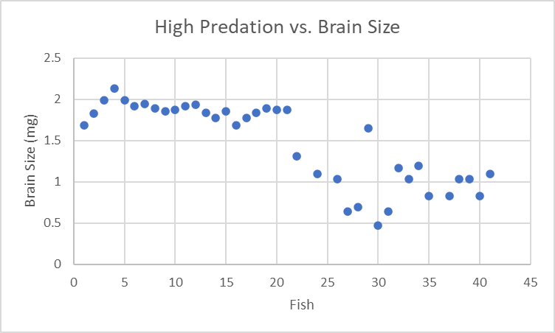X Y Scatter Plot*

**Discussion**

The Pearson’s coefficient and X Y scatter plots showed significance in agreement with the proposed hypothesis.

Work Cited

Dunlap, Kent D., et al. “Predation Drives the Evolution of Brain Cell Proliferation and Brain Allometry in Male Trinidadian Killifish, Rivulus Hartii.” *Proceedings of the Royal Society B: Biological Sciences*, vol. 286, no. 1917, 2019, p. 20191485., doi:10.1098/rspb.2019.1485.

Gonda, Abigél, et al. “Brain Development and Predation: Plastic Responses Depend on Evolutionary History.” *Biology Letters*, vol. 8, no. 2, 2011, pp. 249–252., doi:10.1098/rsbl.2011.0837.

Kotrschal, Alexander, et al. “Predation Pressure Shapes Brain Anatomy in the Wild.” *Evolutionary Ecology*, vol. 31, no. 5, 2017, pp. 619–633., doi:10.1007/s10682-017-9901-8.

Walsh, Matthew R., et al. “Predator-Driven Brain Size Evolution in Natural Populations of Trinidadian Killifish ( Rivulus Hartii ).” *Proceedings of the Royal Society B: Biological Sciences*, vol. 283, no. 1834, 2016, p. 20161075., doi:10.1098/rspb.2016.1075.